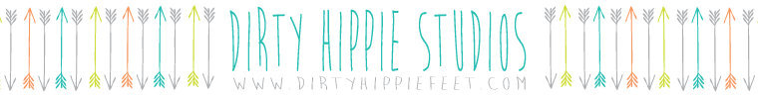

Standard Photo and Video Release Form for Minor Children

I hereby authorize Dirty Hippie Studios (which includes Hipsqueak + Co. and Hipsqueak & Mums) to publish the photographs and videos taken of me and/or the undersigned minor children, and our names, for use for promotional/advertising purposes in print production, social media, and website.

I release Dirty Hippie Studios from any expectation of confidentiality for the undersigned minor children and myself and attest that I am the parent or legal guardian of the children listed below and that I have the authority to authorize the Dirty Hippie Studios to use their photographs, videos and names.

I acknowledge that since participation in publications and websites produced by Dirty Hippie Studios is voluntary, neither the minor children nor I will receive financial compensation.

I further agree that participation in any publication and website produced by Dirty Hippie Studios confers no rights of ownership whatsoever. I release Dirty Hippie Studios, its contractors and its employees from liability for any claims by me or any third party in connection with my participation or the participation of the undersigned minor children.

Name: _________________________________________________________________________________

Signature: _____________________________________ Date: ________________________________

Street Address: _______________________________________________________________________

City, State, Zip: ________________________________________________________________________

Name and Age of Minor Child:

Name: _____________________________________________________ Age: ______________________

DIRTY HIPPIE STUDIOS
2525 TAFT STREET, SACRAMENTO, CA 95815
WWW.DIRTYHIPPIEFEET.COM
(916) 239-5949

