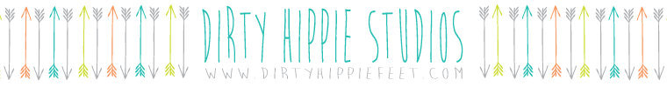
PHOTOGRAPH COPYRIGHT RELEASE FORM

I, hereby grant permission to Dirty Hippie Studios (which includes Hipsqueak + Co. and Hipsqueak & Mums) to reproduce any portion of the photo images that have been taken by me, ___________________________ (Photographer’s full name), for the purpose of SELF USE and or SELF PROMOTION publications which can include but is not limited to, books, cards, calendars, invitations, all social media and websites without any more compensation or recognition given to me. I grant creative permission to alter the photograph(s). I do not grant permission to resale or use the photographs in a manner that would exploit or cause malicious representation toward me.

Permission is granted for all photos containing Dirty Hippie Studios products and submitted to the company or publicly shared by me.

Any infringements of this policy may violate federal law.

Photographer Information:
Name: __________________________________________________________________
Mailing Address: __________________________________________________________
City: _________________________________ State: ___________ Zip: ______________
Signed (photographer/agent): _______________________________________________ Date Signed: ____________

DIRTY HIPPIE STUDIOS
2525 TAFT STREET, SACRAMENTO, CA 95815
WWW.DIRTYHIPPIEFEET.COM
(916) 239-5949

